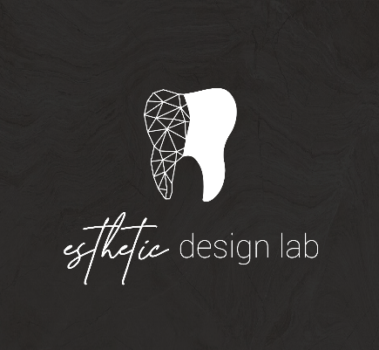
How to add Esthetic Design Dental Lab to 3M Scanners

- Call 3M at 800-634-2449, extension 3 for digital OR extension 1 for general assistance
- Ask the 3M support team to be connected to Esthetic Design Lab to be able to submit scans via the 3M True Def Scanner

Please let us know if you experience any issues when sending us cases, we will help along the way.

