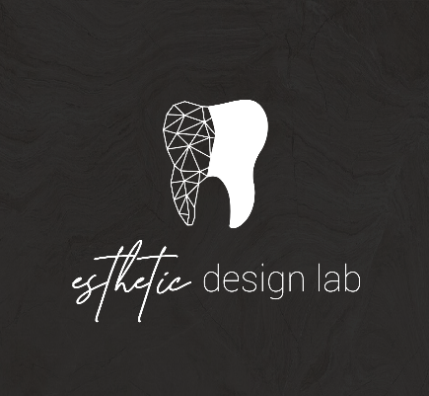

How to add Esthetic Design Dental Lab to Sirona Scanners
Includes CEREC, Connect 4.x, Primescan

Log in to Cerec Connect at www.sirona-connect.com
- Select “My Cerec Connect,” then “Edit Account”
- Under “My Account,” select “My Favorite Laboratories”
- Type “Esthetic Design Lab” in the field for “Company Name,” then “32256” for Zip Code
- Click “FIND”
- Check the box that says “Esthetic Design Lab”
- Click “ADD” to complete the registration
- When sending a case, add “Send to Esthetic Design Lab” in the notes

