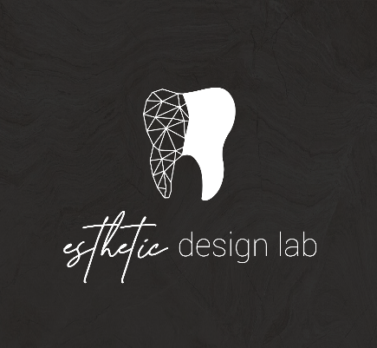
How to add Esthetic Design Dental Lab to iTero Scanners

Option 1
- Select “Find a Laboratory” on your iTero scanner
- Connect with Esthetic Design Lab using our Company Email: office@estheticdesignlab.com
- After connecting to us as a Lab, select “Esthetic Design Lab” on your scanner when sending files

Option 2
- Call 800-577-8767
- Select Option 1
- Request that Esthetic Design Lab is added to your scanner. Identify our lab using our phone number (904)456-8570
- After Esthetic Design Lab has been added, restart your scanner
- After connecting to us as a Lab, select Esthetic Design Lab on your scanner when sending files

Please let us know if you experience any issues when sending us cases, we will help along the way.

