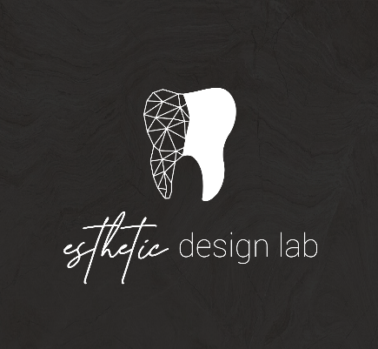
How to add Esthetic Design Dental Lab to Medit Scanners

- Go to the Medit link website and create an account.
- Log in to your account.
- Click on “Partners” on the left side.
- Type office@estheticdesignlab.com in the search bar.
- Find Esthetic Design Lab and click “Request Partnership.”
- Check the details and press “Request Partnership” again.
We will approve your request quickly, and your status will update to “Partners.”
Please let us know if you experience any issues with sending your cases to the lab.

